**RATHNAVEL SUBRAMANIAM COLLEGE OF ARTS AND SCIENCE, (AUTONOMOUS), SULUR, COIMBATORE – 641 402 POST GRADUATE AND RESEARCH SCHOOL OF COMMERCE**

**SUBJECT: MICRO ECONOMICS DATE: 15th SEP 2022 TOPIC: THE BASIC ECONOMIC PROBLEM SUBTOPICS COVERED: OPPORTUNITY COST, PRODUCTION POSSIBILITY CURVE SECOND WEEK: Quiz, Activities (Individual, Group) and Assignments QUIZ – In Google Classroom**

**INDIVIDUAL ACTIVITIES**

1. In each of the following cases, consider what might be the opportunity cost. a. A person wanting to buy fruit, but decides to buy apples b. A person decides to study economics at a university c. A factory is built on farm land d. A woman has a television set which cost her $800 two years ago. A new set would cost her $1000 and she could sell her television set for $450. What is the opportunity cost of keeping the old television?
2. Look at the graph and answer the questions.

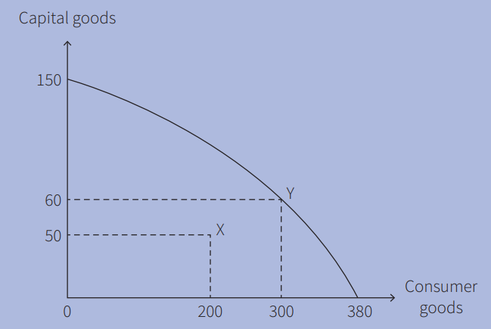

Fig. A country’s PPC

1. If a country is producing at point X, what is its output of capital goods and consumer goods?

2. If a country’s output moves from point X to point Y, how many more capital goods and how many more consumer goods will it produce?

3. What is the maximum number of capital goods that can be produced if all resources are devoted to capital goods?

1. Using Figure,

1 State the maximum number of capital goods the country can produce if it devotes all of its resources to making capital goods.

2 Calculate the opportunity cost of increasing the output of consumer goods from 80 to 90 units.

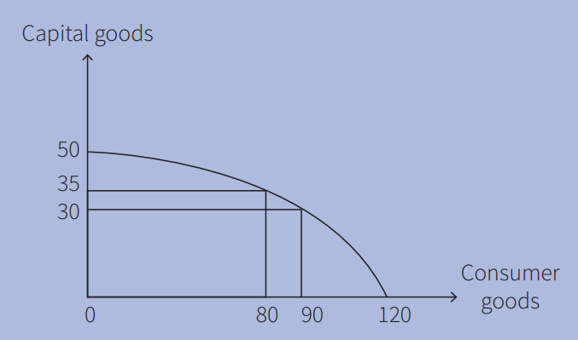

Fig. A country’s PPC

**GROUP ACTIVITIES**

1. In your group, discuss why the opportunity cost of working as an accountant is likely to be higher than that of working as a window cleaner.
2. In your group, discuss and decide whether the following will cause a shift of a country’s PPC to the left or the right: a advances in technology b a rise in the retirement age c improved education d widespread floods e worn out capital goods not being replaced

**ASSIGNMENTS**

**DEFINITIONS:** Match the following terms with an appropriate definition.

|  |  |
| --- | --- |
| 1. Scarcity | 1. Natural resources |
| 1. The economic problem | 1. Economic resources |
| 1. Wants | 1. Inability of workers to change jobs and location |
| 1. Land | 1. Inability to produce everything that people want |
| 1. Capital | 1. Products that have an opportunity cost |
| 1. Labour immobility | 1. Products that do not have an opportunity cost |
| 1. Factors of production | 1. Products people desire to have |
| 1. Opportunity cost | 1. Human made resources |
| 1. Economic goods | 1. An insufficient quantity to satisfy everyone’s wants |
| 1. Free goods | 1. Best alternative foregone |
| 1. Allocation of resources | 1. An output combination to the right of the PPC |
| 1. Entrepreneurs | 1. Buyers of goods and services |
| 1. Unattainable production point | 1. A payment for the use of land |
| 1. Consumers | 1. People who bear the risks of a business and who organize the other factors of production |
| 1. Rent | 1. What land, labour, capital and enterprise are used to produce |

**MISSING WORDS:** Complete the following sentences by filling in the missing word or words.

1. Another name for a production possibility curve is a _______________ cost curve.
2. A production possibility cure shows the maximum output of ________________ products with existing resources and ______________.

**SIMILARITIES:** Identify one way in which, each of the following pairs is similar.

1. Production possibility curves and production possibility frontiers
2. A production point inside a production possibility curve and a production point on the production possibility curve
3. Wages and profit
4. A movement along and a shift in a production possibility curve

**DIFFERENCES:** Identify one way in which, each of the following pairs is different.

1. Geographical immobility and occupational immobility
2. Opportunity cost and financial cost
3. An increase in the quantity of an economy’s factors of production and an increase in the quality of an economy’s factors of production
4. A production point on a production possibility curve and a production point to the right of a production possibility curve

**QUESTIONS**

1. On his birthday, Kamran receives $200 from his aunt, $50 of which he decides to save. He is taken out by his father for lunch. His father pays the bill. Kamran spends the afternoon playing football. Which of these activities involves an opportunity cost?

|  |  |  |  |
| --- | --- | --- | --- |
|  | Eating the free lunch | Playing football | Saving |
| A | NO | NO | NO |
| B | NO | NO | YES |
| C | NO | YES | YES |
| D | YES | YES | YES |

1. Four firms can produce soap and perfumes. The table shows the maximum number of bars of soap and bottles of perfumes, thjat each firm can make each day if they specialize in one type of products.

|  |  |  |
| --- | --- | --- |
|  | Bars of soap | Bottles of perfume |
| Firm W | 50 | 10 |
| Firm X | 60 | 12 |
| Firm Y | 64 | 16 |
| Firm Z | 90 | 20 |

1. Which type of factors of production are a football stadium and an owner of a football club?

|  |  |  |
| --- | --- | --- |
|  | Football stadium | Owner of a football club |
| A | Capital | Entrepreneur |
| B | Capital | Labour |
| C | Land | Entrepreneur |
| D | Land | Labour |

1. A firm employs 26 workers, paying each one $75 a week. What is the Firm’s total wage cost? A country produces $900 million capital goods in a year. There is depreciation of $620 million. What is net investment?
2. Draw a production possibility curve showing the effect of an increase in the quantity of resources.

**Table of Contents**

**Syllabus matching grid**  
**1 The basic economic problem**  
**1.1 The nature of the economic problem**  
1.1.1: Finite resources and unlimited wants  
1.1.2: Economic and free goods  
**1.2 Factors of production**  
1.2.1: Definitions of the factors of production and their rewards  
1.2.2: Mobility of the factors of production  
1.2.3: Quantity and quality of the factors of production  
**1.3 Opportunity cost**  
1.3.1: Definition of opportunity cost  
1.3.2: The influence of opportunity cost on decision making  
**1.4 Production possibility curves (PPC)**  
1.4.1: Definition of PPC  
1.4.2: Points under, on and beyond a PPC  
1.4.3: Movements along a PPC  
1.4.4: Shifts in a PPC  
**2 The allocation of resources**  
**2.1 Microeconomics and macroeconomics**  
2.1.1: Microeconomics  
2.1.2: Macroeconomics  
**2.2 The role of markets in allocating resources**  
2.2.1: The market system  
2.2.2: Key resources allocation decisions  
2.2.3: Introduction to the price mechanism  
**2.3 Demand**  
2.3.1: Definition of demand  
2.3.2: Price and demand  
2.3.3: Individual and market demand  
2.3.4: Conditions of demand  
**2.4 Supply**  
2.4.1: Definition of supply  
2.4.2: Price and supply  
2.4.3: Individual and market supply  
2.4.4: Conditions of supply  
**2.5 Price determination**  
2.5.1: Market equilibrium  
2.5.2: Market disequilibrium  
**2.6 Price changes**  
2.6.1: Causes of price changes  
2.6.2: Consequences of price changes  
**2.7 Price elasticity of demand (PED)**  
2.7.1: Definition of PED  
2.7.2: Calculation of PED  
2.7.3: Determinants of PED  
2.7.4: PED and total spending on a product/revenue  
2.7.5: Significance of PED  
**2.8 Price elasticity of supply (PES)**  
2.8.1: Definition of PES  
2.8.2: Calculation of PES  
2.8.3: Determinants of PES  
2.8.4: Significance of PES  
**2.9 Market economic system**  
2.9.1: Definition of market economic system  
2.9.2: Advantages and disadvantages of the market economic system  
**2.10 Market failure**  
2.10.1: Definition of market failure  
2.10.2: Causes of market failure  
2.10.3: Consequences of market failure  
**2.11 Mixed economic system**  
2.11.1: Definition of the mixed economic system  
2.11.2: Government intervention to address market failure  
**3 Microeconomic decision makers**  
**3.1 Money and banking**  
3.1.1: Money  
3.1.2: Banking  
**3.2 Households**  
3.2.1: Influences on spending, saving and borrowing  
**3.3 Workers**  
3.3.1: Factors affecting an individual's choice of occupation  
3.3.2: Wage determination  
3.3.3: Reasons for differences in earnings  
3.3.4: Division of labour/specialization  
**3.4 Trade unions**  
3.4.1: Definition of a trade union  
3.4.2: The role of trade unions in the economy  
3.4.3: The advantages and disadvantages of trade union activity  
**3.5 Firms**  
3.5.1: Classification of firms  
3.5.2: Small firms  
3.5.3: Causes and forms of the growth of firms  
3.5.4: Mergers  
3.5.5: Economies and diseconomies of scale  
**3.6 Firms and production**  
3.6.1: Demand for factors of production  
3.6.2: Labour-intensive and capital-intensive production

1. 3.6.3: Production and productivity  
   **3.7 Firms' costs, revenues and objectives**  
   3.7.1: Definition of costs of production  
   3.7.2: Calculation of costs of production  
   3.7.3: Definition of revenue  
   3.7.4: Calculation of revenue  
   3.7.5: Objectives of firms  
   **3.8 Market structure**  
   3.8.1: Competitive markets  
   3.8.2: Monopoly markets  
   **4 Government and the macroeconomy**  
   **4.1 The role of government**  
   4.1.1: The role of government  
   **4.2 The macroeconomic aims of government**  
   4.2.1: The macroeconomic aims of government  
   4.2.2: Possible conflicts between macroeconomic aims  
   **4.3 Fiscal policy**  
   4.3.1: Definition of the budget  
   4.3.2: Reasons for government spending  
   4.3.3: Reasons for taxation  
   4.3.4: Classification of taxes  
   4.3.5: Principles of taxation  
   4.3.6: Impact of taxation  
   4.3.7: Definition of fiscal policy  
   4.3.8: Fiscal policy measures  
   4.3.9: Effects of fiscal policy on government macroeconomic aims  
   **4.4 Monetary policy**  
   **4.5 Supply-side policy**  
   4.5.1: Definition of supply-side policy  
   4.5.2: Supply-side policy measures  
   4.5.3: Effects of supply-side policy measures on government macroeconomic aims  
   **4.6 Economic growth**  
   4.6.1: Definition of economic growth  
   4.6.2: Measurement of economic growth  
   4.6.3: Causes and consequences of recession  
   4.6.4: Causes of economic growth  
   4.6.5: Consequences of economic growth  
   4.6.6: Consequences of economic growth  
   **4.7 Employment and unemployment**  
   4.7.1: Definition of employment, unemployment and full employment  
   4.7.2: Changing patterns and level of employment  
   4.7.3: Measurement of unemployment  
   4.7.4: Causes/types of unemployment  
   4.7.5: Consequences of unemployment  
   4.7.6: Policies to reduce unemployment  
   **4.8 Inflation and deflation**  
   4.8.1: Definition of inflation and deflation  
   4.8.2: Measurement of inflation and deflation  
   4.8.3: Causes of inflation and deflation  
   4.8.4: Consequences of inflation and deflation  
   4.8.5: Policies to control inflation and deflation  
   **5 Economic development**  
   **5.1 Living standards**  
   5.1.1: Indicators of living standards  
   5.1.2: Comparing living standards and income distribution  
   **5.2 Poverty**  
   5.2.1: Definition of absolute and relative poverty  
   5.2.2: The causes of poverty  
   5.2.3: Policies to alleviate poverty and redistribute income  
   **5.3 Population**  
   5.3.1: The factors that affect population growth  
   5.3.2: Reasons for different rates of population growth in different countries  
   5.3.3: The effects of changes in the size and structure of population on different countries  
   **5.4 Differences in economic development between countries**  
   5.4.1: Differences in economic development between countries  
   **6 International trade and specialization**  
   **6.1 International specialization**  
   6.1.1: Specialization at a national level  
   6.1.2: Advantages and disadvantages of specialization at a national level  
   **6.2 Globalization, free trade and protection**  
   6.2.1: Definition of globalization  
   6.2.2: Role of multinational companies (MNCs)  
   6.2.3: The benefits of free trade  
   6.2.4: Methods of protection  
   6.2.5: Reasons for protection  
   6.2.6: Consequences of protection  
   **6.3 Foreign exchange rates**  
   6.3.1: Definition of foreign exchange rate  
   6.3.2: Determination of foreign exchange rate in foreign exchange market  
   6.3.3: Causes of foreign exchange rate fluctuations  
   6.3.4: Consequences of foreign exchange rate fluctuations  
   6.3.5: Floating and fixed foreign exchange rates  
   **6.4 Current account of balance of payments**  
   6.4.1: Structure  
   6.4.2: Causes of current account deficit and surplus  
   6.4.3: Consequences of current account deficit and surplus  
   6.4.4: Policies to achieve balance of payments stability